Required Merchant Information
Environment: | DEMO / PRODUCTION
Merchant ID:
Public IP (the connection established to SFTP):
SSH Public Key for Authentication (RSA 2048):

PuTTY Key Generator
https://www.ssh.com/academy/ssh/putty/windows/puttygen
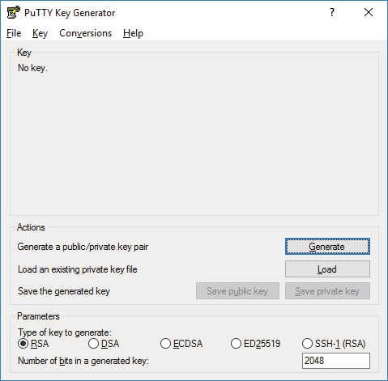
2C2P Information
2C2P IP | 52.76.184.174
2C2P Port | 22
Request Path | /input
Response Path | /output

